Node.js Installation

# Node.Js installations guides

1. **Download the Windows installer from the**[**Nodes.js® web site**](http://nodejs.org/)**.**
2. **Run the installer** (the .msi file you downloaded in the previous step.)

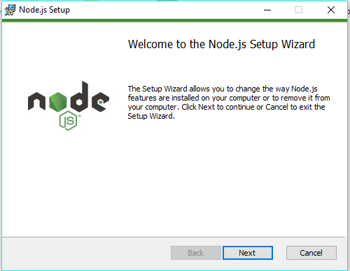

1. **Follow the prompts in the installer** (Accept the license agreement, click the NEXT button a bunch of times and accept the default installation settings).  
   [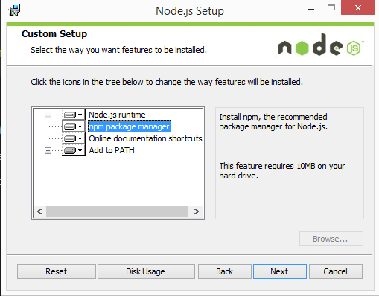](http://blog.teamtreehouse.com/wp-content/uploads/2015/01/installer.png)
2. **Restart your computer.** You won’t be able to run Node.js® until you restart your computer.

## Output

